Report: Laboratory work 2

**Comparison of exponential and running mean for random walk model**

Team #1: Viktor Liviniuk, Alina Liviniuk, Sergei Vostrikov

In this work we compare the errors of exponential and running mean. The goal is to determine the most effective quasi-optimal estimation method in conditions of uncertainty.

**Part 1.** Determination of optimal smoothing constant in exponential mean

Here we conduct a simulation by generating 2 trajectories and simulating measurements of them. Both trajectory has normally distributed random steps with zero mathematical expectation, variance 10 and starts at 10. First one is 3000 steps long and second one is 300 steps long. Measurements have normally distributed random noise with zero mathematical expectation and variance 15.

We identify 𝜎𝑤2 and 𝜎𝜂2 to compare estimation results with their true values. Here are estimations on few iterations:

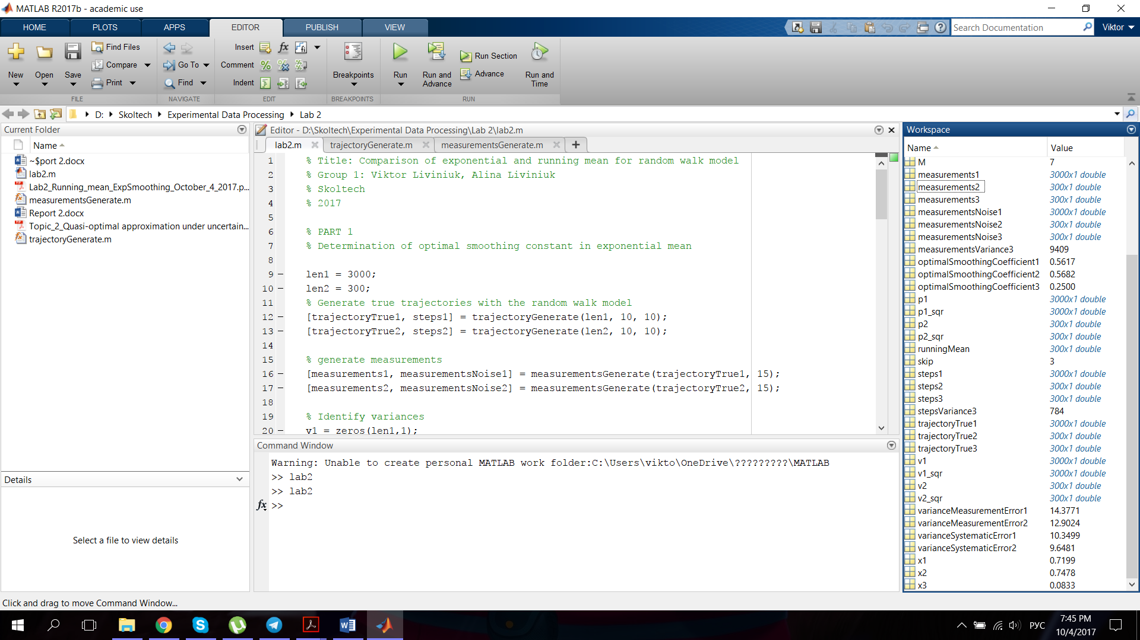

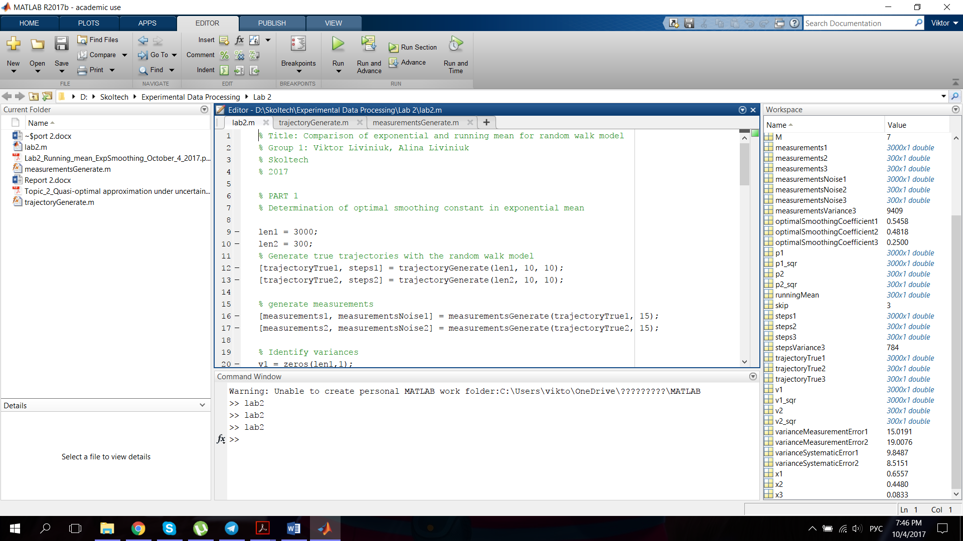

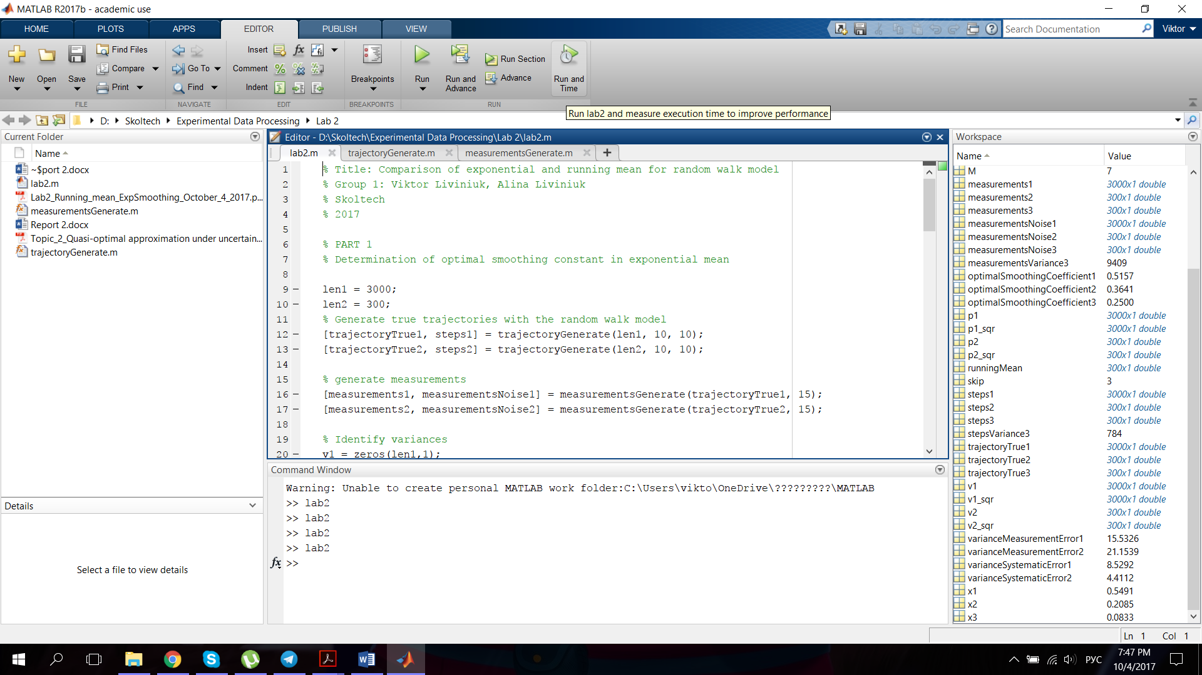

In first experiment estimations are closer to the true values of 𝜎𝑤2 and 𝜎𝜂2. In the second experiment dispersion is higher because of smaller number of steps in the random walking model. But still, if we take mean values of several iterations of the simulations, they are close to real ones. Several examples:

We also determined optimal smoothing coefficient in exponential smoothing. The dispersion for this values are even higher (especially for the second one), as they depend on both variance values. Several examples:

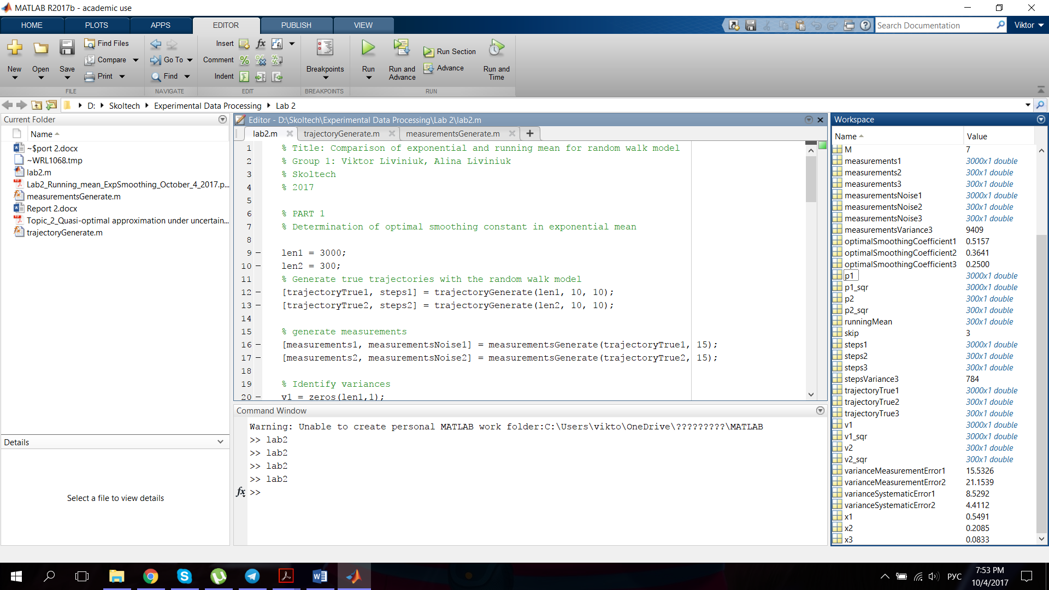

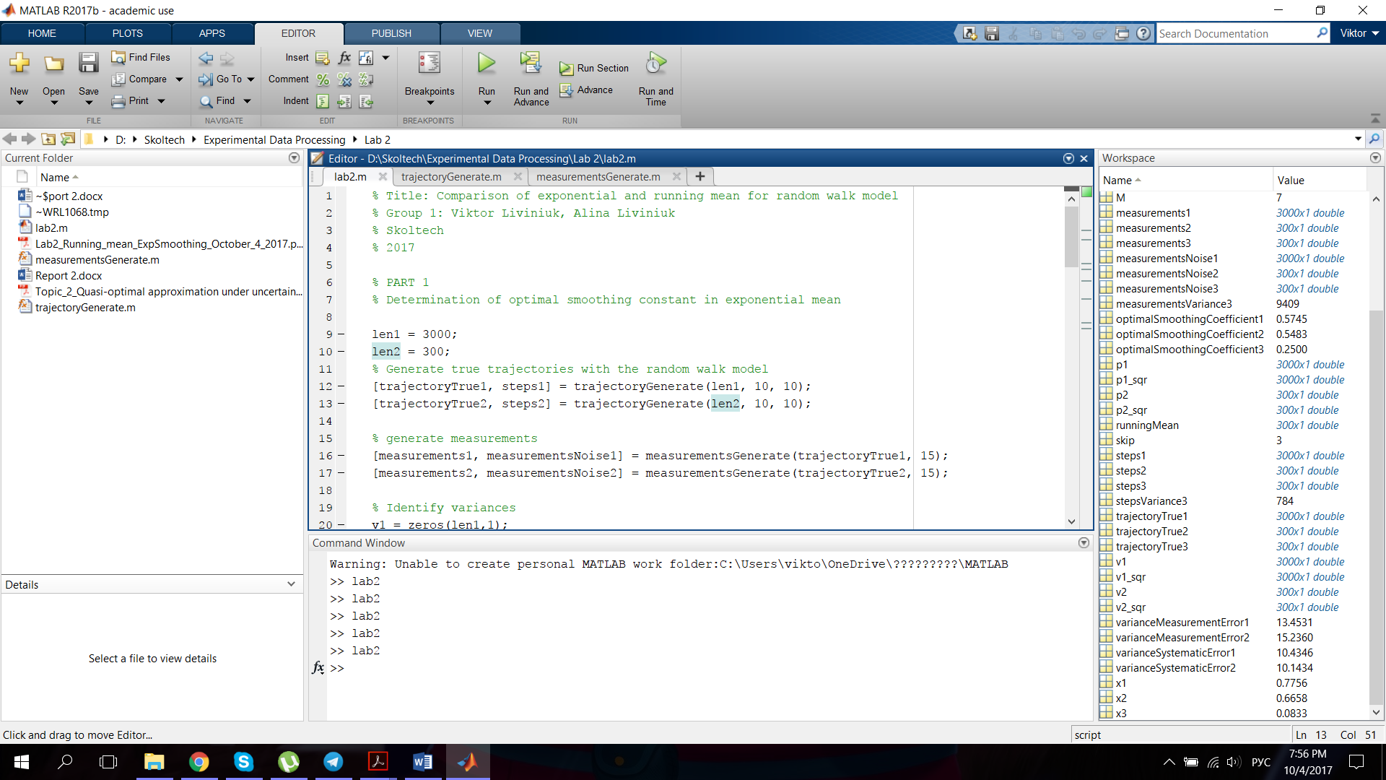

**Part 2.** Comparison of methodical errors of exponential and running mean.

Here we simulated a 300-step trajectory. It had normally distributed random steps with zero mathematical expectation, variance 282 and started at 10. Generated measurements had variance of noise 972.

Optimal smoothing coefficient 𝛼 = 0.25.

Window size M = 7.

Then we applied running mean using determined window size 𝑀 and exponential mean.

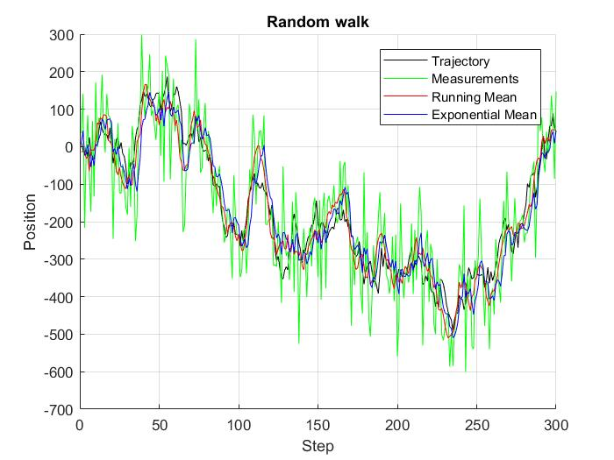

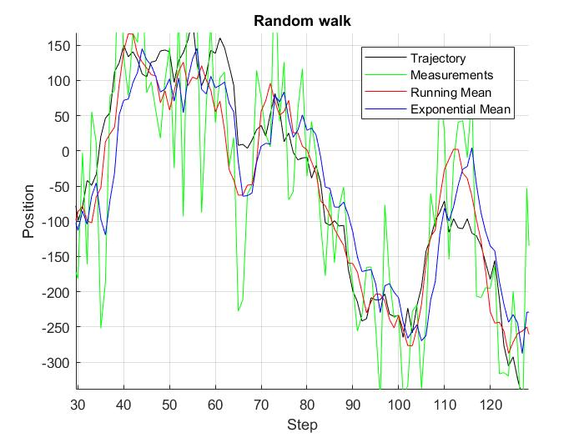

Conclusions. As can be seen on the zoomed region of the plot, running mean is better for this particular generated trajectory. Exponential mean gives a delay in this case. It is very important to minimize delay in prediction.

Files with the matlab code are attached.